Example of QBIN Recipe Competition Submission

Recipe Name: “Somebody-Love-Reviewer-Number-Two”

Description: Bitter-sweet cocktail, made without love but a lot of sweat.
Harsh at first, might just need a bit of sweetness.

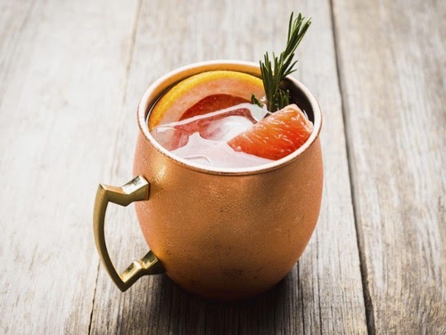

Ingredients:
-1/2 Grapefruit (not the better half)
-Gin (2 ounces) – (we recommend discovering the selection of gins from Quebec)
-Ginger root (1 ounce)
-1 cup of Boiling water (that’s where the sweat comes from!)
-Quebec honey (optional)
-Decorative: branch of pine tree

Instructions
Infuse grapefruit and ginger. Let it sit for 5 minutes.
Add gin and honey to taste. Decorate with pine tree branches.

Author(s): Isabelle Arseneau-Bruneau & Giulia Baracchi
Affiliations: McGill University - Montreal Neurological Institute

