12th International Indigenous Librarians’ Forum Proceedings Submission Guidelines for Full Paper Submissions

Please format your IILF Hawaiʻi Proceedings Full Paper according to the following style checklist and paper template.

Style checklist
- Chicago Manual of Style 17th edition –https://owl.purdue.edu/owl/research_and_citation/chicago_manual_17th_edition/cmos_formatting_and_style_guide/general_format.html

- 12-point Times New Roman font for body text

- All body text left justified and double spaced

- Indent new paragraphs.

- Set page size to Letter (8.5” x 11”).

- Margins: Microsoft Word ‘Normal’ (1”).

- Main headings, subheadings, and sub-subheadings should be formatted as in the example below. No more than three levels of headings should be included.

- All figures, images, and tables must be inserted in a .jpg or .png image (or table) format, within the page margins. Center figures, images, and tables. Number and caption below the figure and table (Figure 1: Caption), center-aligned. Be sure to also upload all images and figures as separate files when submitting this paper.

- Do not use any page headers, footers, or page numbers. Footnotes are acceptable for explanatory notes.

- Use only portrait layout. Do not include any pages in landscape layout.

Title of Paper [Size 14, bold, italicized]

Author 1, Name of Affiliation(s), Email
Author 2, Name of Affiliation(s), Email [if applicable – add as many co-authors as needed]

Abstract [Maximum of 250 Words]
Lorem ipsum dolor sit amet, consectetur adipisicing elit, sed do eiusmod tempor incididunt ut labore et dolore magna aliqua. Ut enim ad minim veniam, quis nostrud exercitation ullamco laboris nisi ut aliquip ex ea commodo consequat. Duis aute irure dolor in reprehenderit in voluptate velit esse cillum dolore eu fugiat nulla pariatur.
Excepteur sint occaecat cupidatat non proident, sunt in culpa qui officia deserunt mollit anim id est laborum. Lorem ipsum dolor sit amet, consectetur adipisicing elit, sed do eiusmod tempor incididunt ut labore et dolore magna aliqua. Ut enim ad minim veniam, quis nostrud exercitation ullamco laboris nisi ut aliquip ex ea commodo consequat. Duis aute irure dolor in reprehenderit in voluptate velit esse cillum dolore eu fugiat nulla pariatur. Excepteur sint occaecat cupidatat non proident, sunt in culpa qui officia deserunt mollit anim id est laborum.
[Body of paper to start on a new page – delete this note before submitting]

Introduction [H1: Arial, size 16, bold]
Lorem ipsum dolor sit amet, consectetur adipisicing elit, sed do eiusmod tempor incididunt ut labore et dolore magna aliqua. Ut enim ad minim veniam, quis nostrud exercitation ullamco laboris nisi ut aliquip ex ea commodo consequat. Duis aute irure dolor in reprehenderit in voluptate velit esse cillum dolore eu fugiat nulla pariatur.
Excepteur sint occaecat cupidatat non proident, sunt in culpa qui officia deserunt mollit anim id est laborum. Lorem ipsum dolor sit amet, consectetur adipisicing elit, sed do eiusmod tempor incididunt ut labore et dolore magna aliqua. Ut enim ad minim veniam, quis nostrud exercitation ullamco laboris nisi ut aliquip ex ea commodo consequat. Duis aute irure dolor in reprehenderit in voluptate velit esse cillum dolore eu fugiat nulla pariatur. Excepteur sint occaecat cupidatat non proident, sunt in culpa qui officia deserunt mollit anim id est laborum.
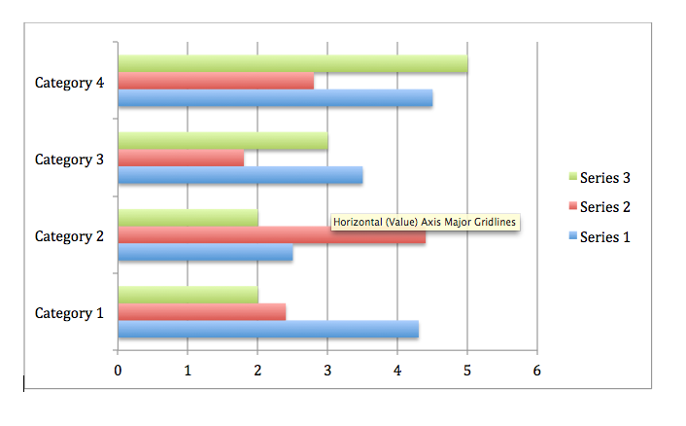
Figure 1: This is a graph.

Subpoint 1 [H2: Arial, size 14, italicized]
Lorem ipsum dolor sit amet, consectetur adipisicing elit, sed do eiusmod tempor incididunt ut labore et dolore magna aliqua. Ut enim ad minim veniam, quis nostrud exercitation ullamco laboris nisi ut aliquip ex ea commodo consequat. Duis aute irure dolor in reprehenderit in voluptate velit esse cillum dolore eu fugiat nulla pariatur. Excepteur sint occaecat cupidatat non proident, sunt in culpa qui officia deserunt mollit anim id est laborum. Lorem ipsum dolor sit amet, consectetur adipisicing elit, sed do eiusmod tempor incididunt ut labore et dolore magna aliqua. Ut enim ad minim veniam, quis nostrud exercitation ullamco laboris nisi ut aliquip ex ea commodo consequat. Duis aute irure dolor in reprehenderit in voluptate velit esse cillum dolore eu fugiat nulla pariatur. Excepteur sint occaecat cupidatat non proident, sunt in culpa qui officia deserunt mollit anim id est laborum.

SUB-SUBPIONT 1 [H3: Arial, size 12, bold, all caps]
Lorem ipsum dolor sit amet, consectetur adipisicing elit, sed do eiusmod tempor incididunt ut labore et dolore magna aliqua. Ut enim ad minim veniam, quis nostrud exercitation ullamco laboris nisi ut aliquip ex ea commodo consequat. Duis aute irure dolor in reprehenderit in voluptate velit esse cillum dolore eu fugiat nulla pariatur. Excepteur sint occaecat cupidatat non proident, sunt in culpa qui officia deserunt mollit anim id est laborum. Lorem ipsum dolor sit amet, consectetur adipisicing elit, sed do eiusmod tempor incididunt ut labore et dolore magna aliqua. Ut enim ad minim veniam, quis nostrud exercitation ullamco laboris nisi ut aliquip ex ea commodo consequat. Duis aute irure dolor in reprehenderit in voluptate velit esse cillum dolore eu fugiat nulla pariatur. Excepteur sint occaecat cupidatat non proident, sunt in culpa qui officia deserunt mollit anim id est laborum.

Conclusion
Lorem ipsum dolor sit amet, consectetur adipisicing elit, sed do eiusmod tempor incididunt ut labore et dolore magna aliqua. Ut enim ad minim veniam, quis nostrud exercitation ullamco laboris nisi ut aliquip ex ea commodo consequat. Duis aute irure dolor in reprehenderit in voluptate velit esse cillum dolore eu fugiat nulla pariatur. Excepteur sint occaecat cupidatat non proident, sunt in culpa qui officia deserunt mollit anim id est laborum. Lorem ipsum dolor sit amet, consectetur adipisicing elit, sed do eiusmod tempor incididunt ut labore et dolore magna aliqua. Ut enim ad minim veniam, quis nostrud exercitation ullamco laboris nisi ut aliquip ex ea commodo consequat. Duis aute irure dolor in reprehenderit in voluptate velit esse cillum dolore eu fugiat nulla pariatur. Excepteur sint occaecat cupidatat non proident, sunt in culpa qui officia deserunt mollit anim id est laborum.

[References to start on a new page – delete this note before submitting]

References

Dean, Jodi. 2009. Democracy and Other Neoliberal Fantasies: Communicative Capitalism and Left Politics. Durham: Duke University Press.
Foucault, Michel. 1984c. “What is an Author?” In The Foucault Reader, edited by Paul Rabinow, 101-20. New York: Pantheon.
Foucault, Michel. 1984d. “What is Enlightenment?” In The Foucault Reader, edited by Paul Rabinow, 32-50. New York: Pantheon.
Hardt, Michael and Antonio Negri. 2000. “Postmodernization, or the Informatization of Production.” In Empire, 280-303. Cambridge, MA: Harvard University Press.

